**Aim**: To Setup and Run Selenium Tests in Jenkins Using Maven.

# Introduction:

## Selenium

Selenium is a portable framework for testing web applications. Selenium is an open-source, test automation tool that has become an important automation tool in the software quality assurance world. This selenium testing tool consists of a different set of tools which include Selenium WebDriver, Selenium RC, Selenium IDE, and Selenium Grid, all of which have different features.

Selenium testing tool is a lightweight tool and is developer-friendly, commonly used for automating web applications. Test automation using selenium webdriver with java, automation testing can be used in any operating system environment such as Windows, Linux, and OS X and has been first developed by Jason Huggins in the year 2004. Cross-browser testing in selenium is an effective selenium testing method used by testers and this tool is also used for web application testing. This selenium testing tool is composed of several components that provide different features.

## Components of Selenium

There are various components of the selenium tool which provide different features that support multiple browsers, deliver parallel test capabilities and can be executed on multiple machines.

It has a suite of tools that cater to different needs of businesses and has the following components:

1. Selenium Remote Control (RC)

Selenium RC supports all major web browsers and this tool interprets commands to convert them into javascript and further these scripts are injected into the browser.

1. Selenium IDE (Selenium Integrated Development Environment)

Selenium IDE is a simple record and playback kind of tool which is available as an add-on for Firefox only.

1. Selenium WebDriver

Selenium WebDriver is one of the vital tools of the Selenium suite and it does not require any manual process like Selenium server and has direct communication between code and browser.

1. Selenium Grid

The Selenium grid is the last component of the selenium suite and is used for parallel testing and sometimes even supports distributive testing.

## Common uses of selenium

Selenium testing tool is commonly used to automate the testing across various web browsers. Cross-browser testing in selenium is most important as it supports various browsers such as Chrome, Mozilla, Firefox, Safari, and IE. Selenium tool can be easily used to automate browser testing across these browsers using Selenium WebDriver.

Selenium testing tool is best suited with an automated testing selenium suite for all web applications across browsers. It delivers good results for all tests as it is an integral part of automation testing.

The complete suite of Selenium software is mainly used to automate web browsers effectively. Selenium UI testing is another testing method that can be done with this tool.

Selenium testing tool is available free of charge and is used for frequent regression testing. Selenium testing enables rapid feedback to developers, as bugs are identified quickly and efficiently. This tool typically supports unlimited iterations of test case execution.

Selenium testing framework supports agile and extreme development methodologies and enables customized defect reporting. Selenium automation testing is used for finding defects that have been undetected by manual testing.

Selenium tool also supports database testing using SQL commands and can be used to conduct database testing.

# Configure Selenium in Jenkins:

## Steps to install TestNG and Maven on Eclipse and use it with Selenium

For this tutorial, we will use Eclipse (Juno) IDE for Java Developers to set up the Selenium

WebDriver Project. Additionally, we need to add the m2eclipse plugin to Eclipse to facilitate the build process and create a pom.xml file.

Let’s add the m2eclipse plugin to Eclipse with the following steps:

Step1) In Eclipse IDE, select Help -> Install New Software from Eclipse Main Menu.

Step 2) On the Install dialog, Enter the URL <http://download.eclipse.org/technology/m2e/releases/>. Select Work with and m2e plugin as shown in the following screenshot: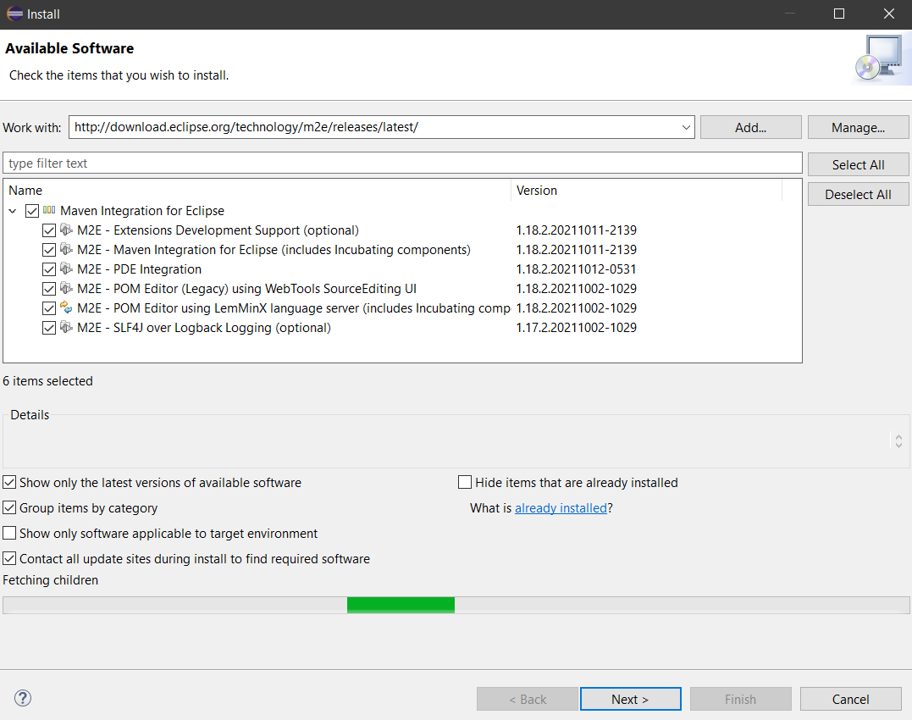

Step 3) Click on the Next button and finish the installation.

## Configure Eclipse with Maven

With the m2e plugin installed, we now need to create a Maven project.

Step 1) In Eclipse IDE, create a new project by selecting File | New | Other from the Eclipse menu.

Step 2) On the New dialog, select Maven | Maven Project and click Next

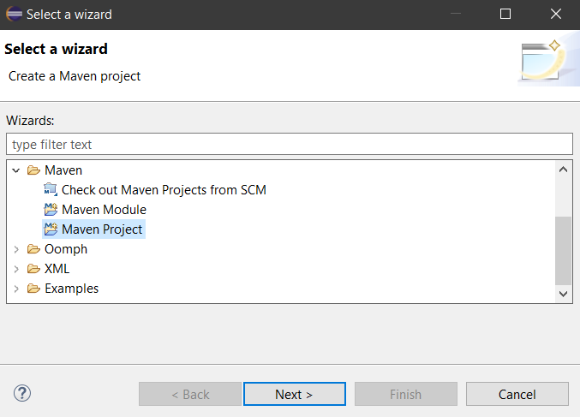

Step 3) On the New Maven Project dialog select the Create a simple project and click Next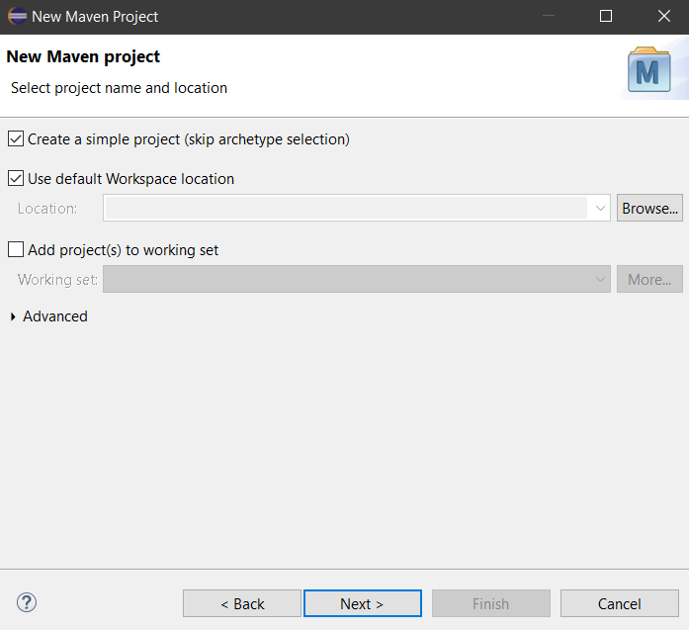

Step 4) Enter WebdriverTest in Group Id: and Artifact Id: and click finish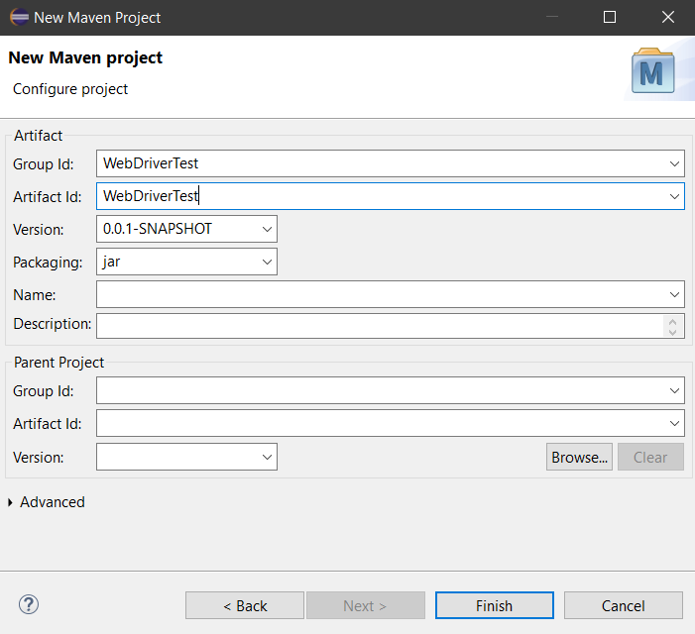

Step 5) Eclipse will create WebdriverTest with following structure: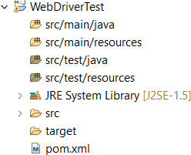

Step 6) Right-click on JRE System Library and select the Properties option from the menu.

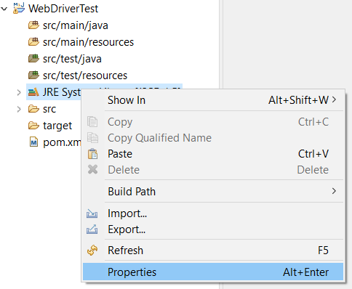

On the Properties for JRE System Library dialog box, make sure Workspace default JRE is selected and click OK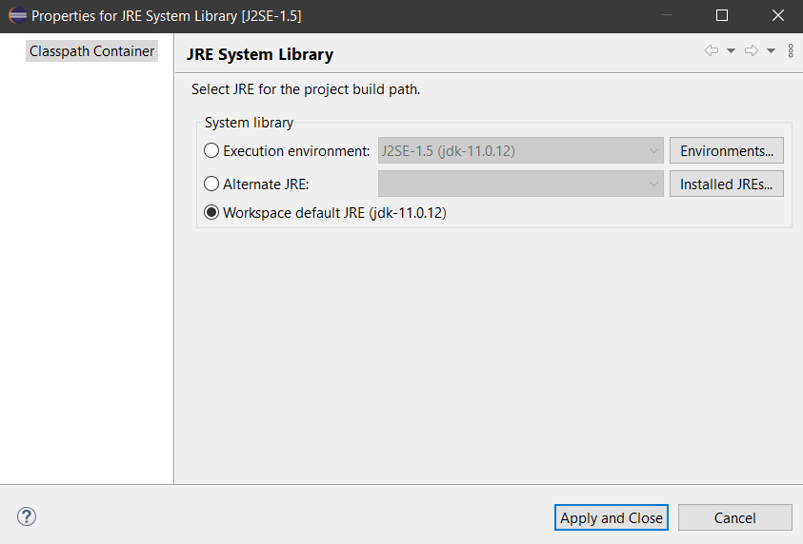

Step 7) Select pom.xml from Project Explorer. pom.xml file will Open in Editor section

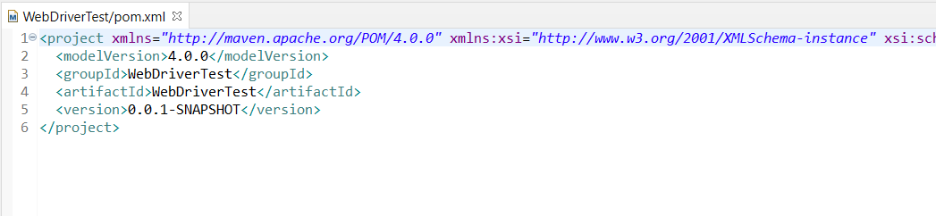

Step 8) Add the Selenium, Maven, TestNG, Junit dependencies to pom.xml in the <project> node:

<dependencies>

<dependency>

<groupId>junit</groupId>

<artifactId>junit</artifactId>

<version>3.8.1</version>

<scope>test</scope>

</dependency>

<dependency>

<groupId>org.seleniumhq.selenium</groupId>

<artifactId>selenium-java</artifactId>

<version>3.12.0</version>

</dependency>

<dependency>

<groupId>org.testng</groupId>

<artifactId>testng</artifactId>

<version>7.4.0</version>

<scope>test</scope>

</dependency>

</dependencies>

Step 9) Create a New TestNG Class. Enter Package name as “example” and “NewTest” in the Name: textbox and click on the Finish button. Eclipse will create the NewTest class as shown.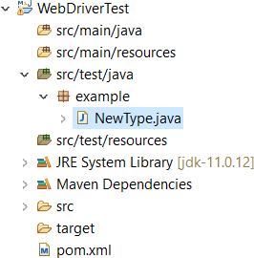

Step 10) Add the following code to the NewTest class:

This code will verify the title of Selenium Page

package example;

import org.openqa.selenium.WebDriver;

import org.openqa.selenium.firefox.FirefoxDriver; import org.testng.Assert;

import org.testng.annotations.Test; import org.testng.annotations.BeforeTest; import org.testng.annotations.AfterTest; public class NewTest {

private WebDriver driver; @Test

public void testEasy() { driver.get("<http://demo.guru99.com/test/guru99home/>"); String title = driver.getTitle(); Assert.assertTrue(title.contains("Demo Guru99 Page"));

}

@BeforeTest

public void beforeTest() { System.setProperty("webdriver.gecko.driver",

"<PATH\\TO\\geckodriver.exe");

driver = new FirefoxDriver();

}

@AfterTest

public void afterTest() { driver.quit();

}

}

Step 11) Right-click on the WebdriverTest and select TestNG | Convert to TestNG. Eclipse will create testng.xml which says that you need to run only one test with the name NewTest.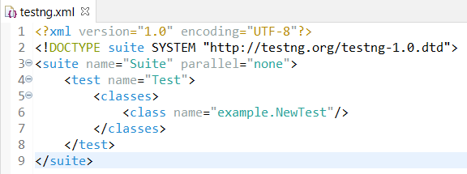

Step 12) Now you need to run the test through this testng.xml.

So, go to the Run Configurations and create a new launch TestNG, select the project and field Suite as testng.xml and click Run.

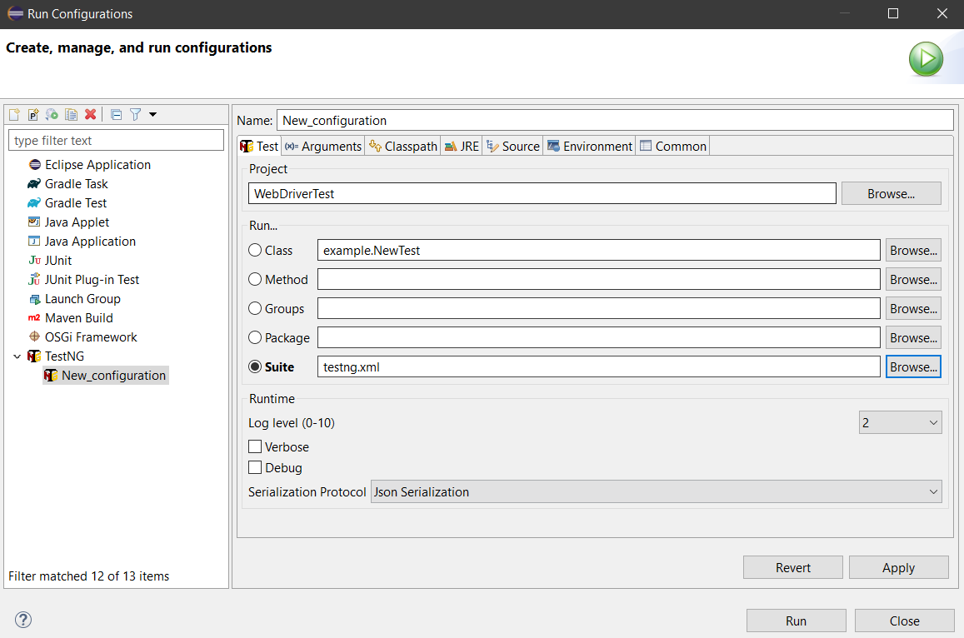

Make sure that the build is finished successfully.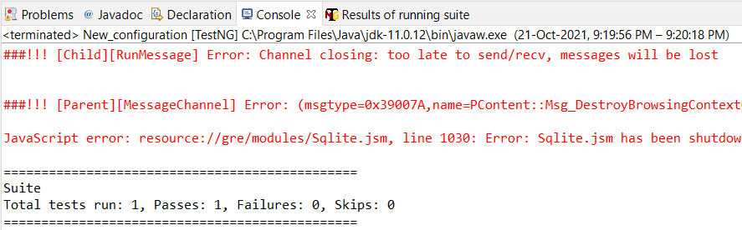

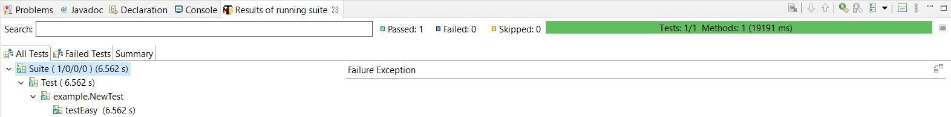

Step 14) Additionally, we need to add

* 1. maven-compiler-plugin
  2. maven-surefire-plugin
  3. testng.xml to pom.xml.

The maven-surefire-plugin is used to configure and execute tests. Here plugin is used to configure the testing.xml for TestNG test and generate test reports.

The maven-compiler-plugin is used to help in compiling the code and using the particular JDK version for compilation. Add all dependencies in the following code snippet, to pom.xml in the

<plugin> node:

<build>

<plugins>

<plugin>

<groupId>org.apache.maven.plugins</groupId>

<artifactId>maven-compiler-plugin</artifactId>

<version>3.8.1</version>

<configuration>

<source>1.8</source>

<target>1.8</target>

</configuration>

</plugin>

<plugin>

<groupId>org.apache.maven.plugins</groupId>

<artifactId>maven-surefire-plugin</artifactId>

<version>2.12</version>

<inherited>true</inherited>

<configuration>

<suiteXmlFiles>

<suiteXmlFile>testng.xml</suiteXmlFile>

</suiteXmlFiles>

</configuration>

</plugin>

</plugins>

<pluginManagement>

<plugins>

<!--This plugin's configuration is used to store Eclipse m2e settings only. It has no influence on the Maven build itself.-->

<plugin>

<groupId>org.eclipse.m2e</groupId>

<artifactId>lifecycle-mapping</artifactId>

<version>1.0.0</version>

<configuration>

<lifecycleMappingMetadata>

<pluginExecutions>

<pluginExecution>

<pluginExecutionFilter>

<groupId>

org.apache.maven.plugins

</groupId>

<artifactId>

maven-compiler-plugin

</artifactId>

<versionRange>

[3.8.2,)

</versionRange>

<goals>

<goal>testCompile</goal>

</goals>

</pluginExecutionFilter>

<action>

<ignore></ignore>

</action>

</pluginExecution>

</pluginExecutions>

</lifecycleMappingMetadata>

</configuration>

</plugin>

</plugins>

</pluginManagement>

</build>

Step 15) To run the tests in the Maven lifecycle, Right-click on the WebdriverTest and select Run As | Maven test. Maven will execute tests from the project.

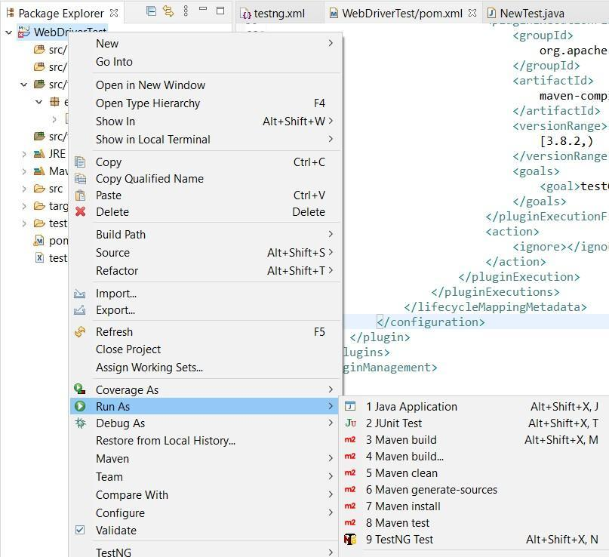

Make sure that build finished successfully.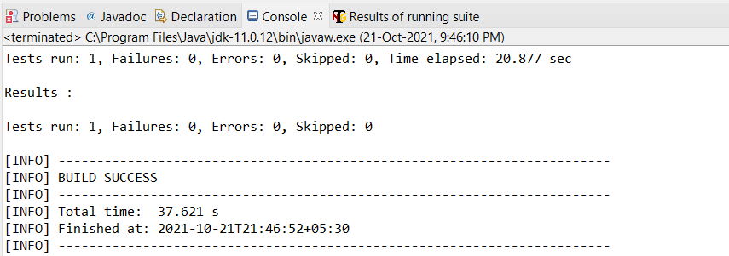

# Setup Test

## Setting up Selenium Project on Jenkins

In the Jenkins dashboard, click New Item to create a new project. Specify the name of the project and click the Maven Project option. Click Ok.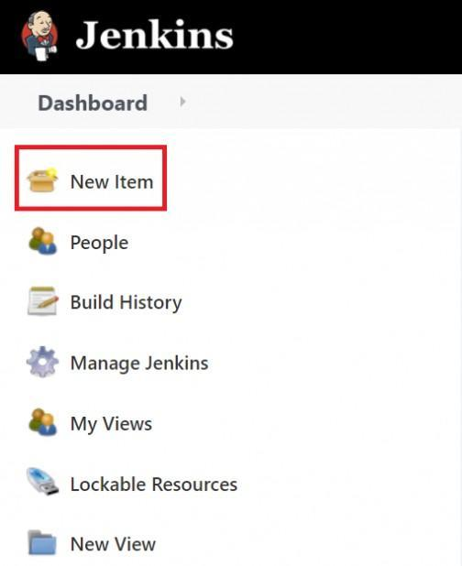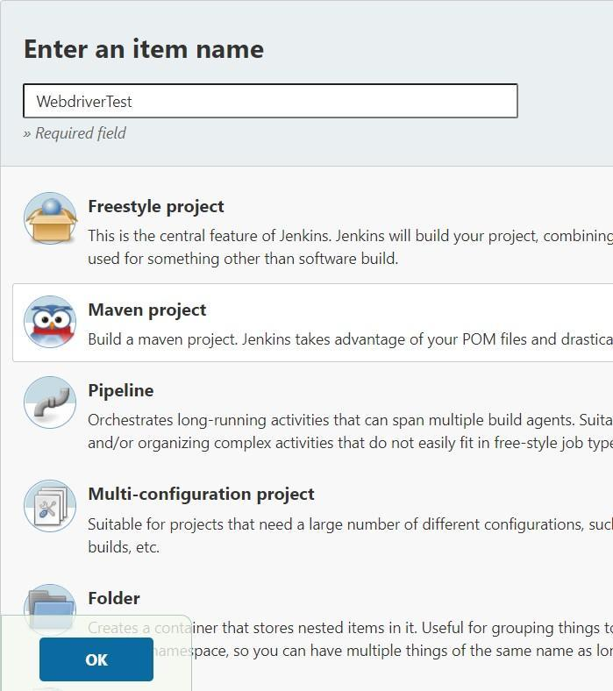

Go to the Build section of your new job.

* + In the Root POM textbox, enter full path to pom.xml
  + In Goals and options section, enter "clean test"
  + Click on Save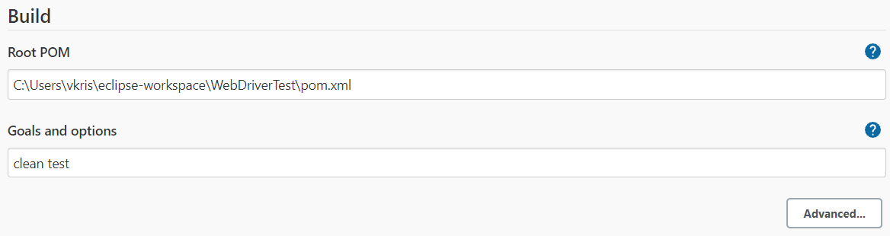

# Setup test:

On the WebdriverTest project page, click on the Build Now link.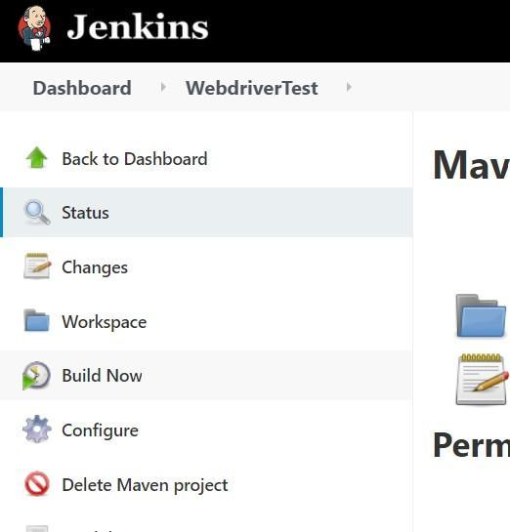

Maven will build the project. It will then have TestNG execute the test cases. Once the build process is completed, check the Console Output.

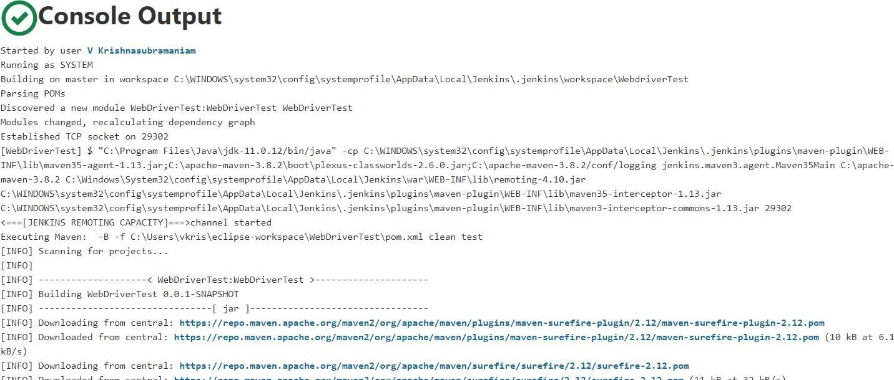



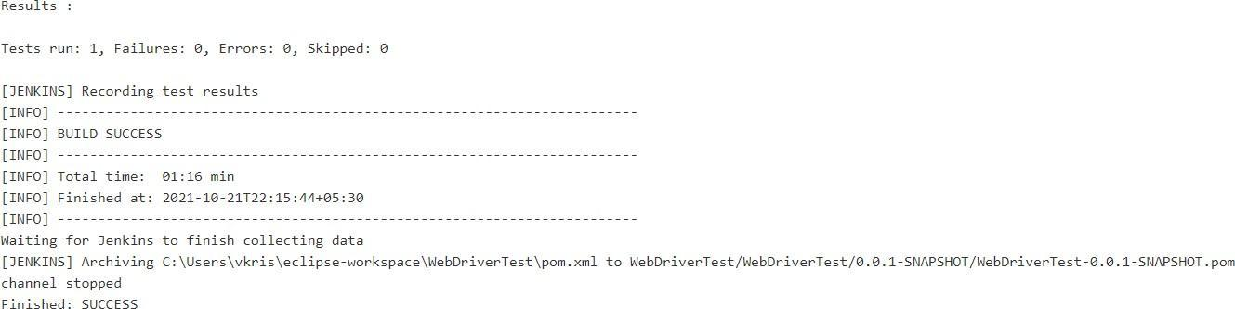

# Conclusion

Thus, we have learnt about Selenium, its benefits and how to use it with a Maven project in Jenkins for automated testing.